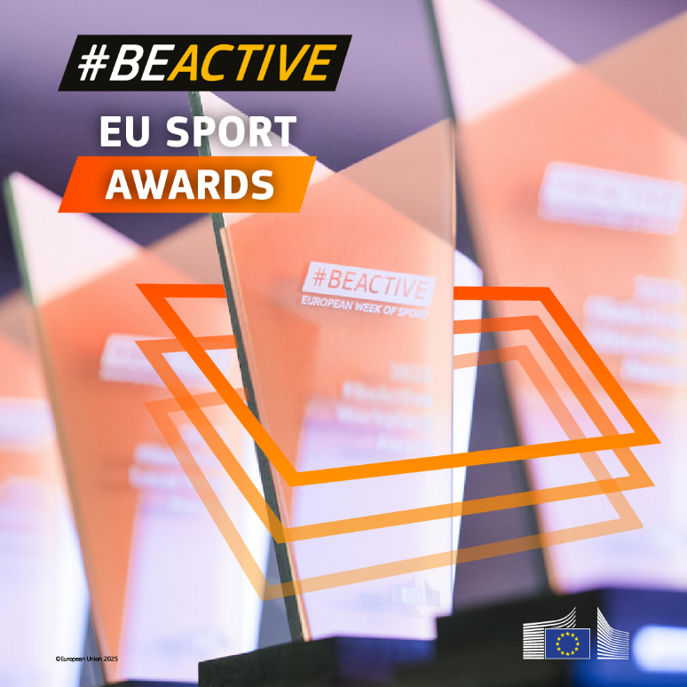

**Erasmus+ programme (ERASMUS)**

**Application Form**

**Administrative Forms (Part A)**

**Technical Description (Part B)**

#BeActive EU Sport Awards

**Version 1.0**

**04.06.2025**

**IMPORTANT NOTICE**

**What is the Application Form?**

The Application Form is the template for EU prize applications; it must be submitted via the EU Funding & Tenders Portal before the call deadline.

The Form consists of 2 parts:

* Part A contains structured administrative information.
* Part B is a narrative technical description of the application.

Part A is generated by the IT system. It is based on the information which you enter into the Portal Submission System screens.

Part B needs to be uploaded as PDF (+ Annexes) in the Submission System. The templates to use are available there.

**How to prepare and submit it?**

The Application Form must be prepared by the Consortium and submitted by a Representative. Once submitted, you will receive a confirmation.

**Character** and **page limits**:

* page limit: **20** pages
* supporting documents can be provided as an annex and do not count towards the page limit
* minimum font size — Arial 9 points
* page size: A4
* margins (top, bottom, left and right): at least 15 mm (not including headers & footers).

Please abide by the formatting rules. They are not a target! Keep your text as concise as possible. Do not use hyperlinks to show information that is an essential part of your project.

 If you attempt to upload an application that exceeds the specified limit, you will receive an automatic warning asking you to shorten and re-upload your application. After you have submitted it, any excess pages will be made invisible and thus disregarded by the evaluators.

 **Please do NOT delete any instructions in the document. The overall page-limit has been raised to ensure equal treatment of all applicants.**

# ADMINISTRATIVE FORMS (PART A)

*Part A of the Application Form must be filled out directly in the Portal Submission System screens.*

# APPLICATION FORM (PART B)

## **COVER PAGE**

*Part B of the Application Form must be downloaded from the Portal Submission System, completed and then assembled and re-uploaded as PDF in the system.*

***Note:*** *Please take due account of the call conditions published on the Portal. Pay particular attention to the award criteria; they explain how the application will be evaluated.*

|  |  |
| --- | --- |
| **PROJECT**[1] | |
| **Project name:** | [title] |
| **Project acronym:** | [acronym] |
| **Coordinator contact:** | [name NAME], [organisation name] |

**TABLE OF CONTENTS**

ADMINISTRATIVE FORMS (PART A) 8

APPLICATION FORM (PART B) 9

COVER PAGE 9

1. SUMMARY 10

2. CONCEPT & METHODOLOGY 10

3. DETAILED DESCRIPTION 10

4. OTHER 11

4.1 Ethics 11

4.2 Security 11

5. DECLARATIONS 12

6. ANNEXES 12

## 1. SUMMARY

|  |
| --- |
| **Project summary** |
| See Proposal Abstract (Part A). |

## 2. CONCEPT & METHODOLOGY

|  |
| --- |
| **Concept & methodology**  *Describe and explain the overall concept underpinning the application. Describe main ideas, models or assumptions involved. Identify any trans-disciplinary considerations.* |
| Insert text |

## 3. DETAILED DESCRIPTION

|  |
| --- |
| **Detailed description of the activity**  Describe the application in detail, specifically addressing each of the award criteria set out in the Rules of Contest *(see also below)* |
| **Award criterion 1: Relevance**  *Depending on each category, applications should describe to what extent the activity:*   * *is aligned with the purpose of the chosen prize, i.e.*   + *for Physical activity: successfully promotes sport and physical activity in the relevant environment, for instance schools, universities and educational establishments, enterprises, sport clubs, local communities, associations, neighbourhoods, etc.,*   + *for Inclusion: tackles some of the barriers that can prevent the target groups from being active, such as lack of time, lack of interest/motivation, disability/illness, cost or other,*   + *for Volunteering: highlights the crucial role volunteers play in fostering community engagement and inspiring positive change in their communities,*   + *for Across generations: promotes inter-generational connections through sport as well as easier access to sport & physical activities for all generations,*   + *for Peace: leverages sport and shared physical activity to foster peaceful coexistence amongst diverse communities,* * *outreaches to citizens with limited access to sport activities,* * *contributes to the fight against discrimination in sport,* * *is relevant for the respect and promotion of shared EU values, such as respect for human dignity, freedom, democracy, equality, the rule of law and respect for human rights, as well as fighting any sort of discrimination.[2]* |
| Insert text |
| **Award criterion 2: Quality**  *Applications should describe the activities implemented, their creative/innovative character, their time schedule and frequency, the type and number of participants, the accessibility for target groups.* |
| Insert text |
| **Award criterion 3: Impact**  *Applications should detail the following:*  *-the impact of the implemented activities on the participants and their communities, from both a qualitative and a quantitative point of view;*  *-the benefits for the participants beyond the sport practice (for example, job placement activities, language learning, empowerment, etc.);*  *-the sustainability of the activity over time and its replicability in another context of the EU*  *-the communication actions, both online and offline,to give visibility to the activity.*  *In the event of an ongoing or recurrent activity, please specify it and describe the results already achieved.* |
| Insert text |

## 4. OTHER

### 4.1 Ethics

|  |
| --- |
| **Ethics**  *Describe ethics issues linked to your application (if any) and the measures you took/intend to take to solve/avoid them.* |
| Insert text |

### 4.2 Security

|  |
| --- |
| **Security**  *Describe security issues linked to your application (if any) and the measures you took/intend to take to solve/avoid them. Indicate if any of the information is/should be EU-classified (Decision* [*2015/444*](https://eur-lex.europa.eu/legal-content/EN/ALL/?uri=CELEX:32015D0444&qid=1586092489803)*).* |
| Not applicable. |

## 5. DECLARATIONS

|  |  |
| --- | --- |
| **Double funding** | |
| **Information concerning other prizes for this project**  cid:image001.png@01D0B99B.7C10A740 *Please note that there is a strict prohibition of double funding from the EU budget (except under EU Synergies calls). Applications that have already received an EU prize cannot receive a second prize for the same activities* | **YES/NO**  (if NO, add details) |
| We confirm that to our best knowledge neither the application as a whole nor any parts of it have benefitted from any other EU prize. |  |
| We confirm that to our best knowledge neither the application as a whole nor any parts of it are (nor will be) submitted for any other EU prize. |  |

## 6. ANNEXES

**LIST OF ANNEXES**

**(Optional)**

|  |  |  |
| --- | --- | --- |
| **HISTORY OF CHANGES** | | |
| VERSION | PUBLICATION DATE | CHANGE |
| 1.0 | 04.06.2025 | Initial version (new MFF). |
|  |  |  |
|  |  |  |
|  |  |  |
|  |  |  |

1. For ease of reference and consistency on the Funding & Tenders Portal, the terms ‘call’, ‘project’, ‘proposal’, ‘coordinator’ or ‘beneficiary’ (or other project-related acronyms like COO or BEN) are used as equivalent to ‘contest’, ‘application’, ‘activity’ or ‘contestants/applicants’.
2. See Article 2 of the Consolidated versions of the Treaty on European Union and the Treaty on the   Functioning of the European Union [2012/C 326/01](https://eur-lex.europa.eu/eli/treaty/teu_2012/oj); Article 21 of the Charter of Fundamental Rights of the European Union [2012/C 326/02](https://eur-lex.europa.eu/legal-content/EN/TXT/?uri=CELEX%3A12012P%2FTXT)